**Statistical Modeling using Python’s Linear Regression**

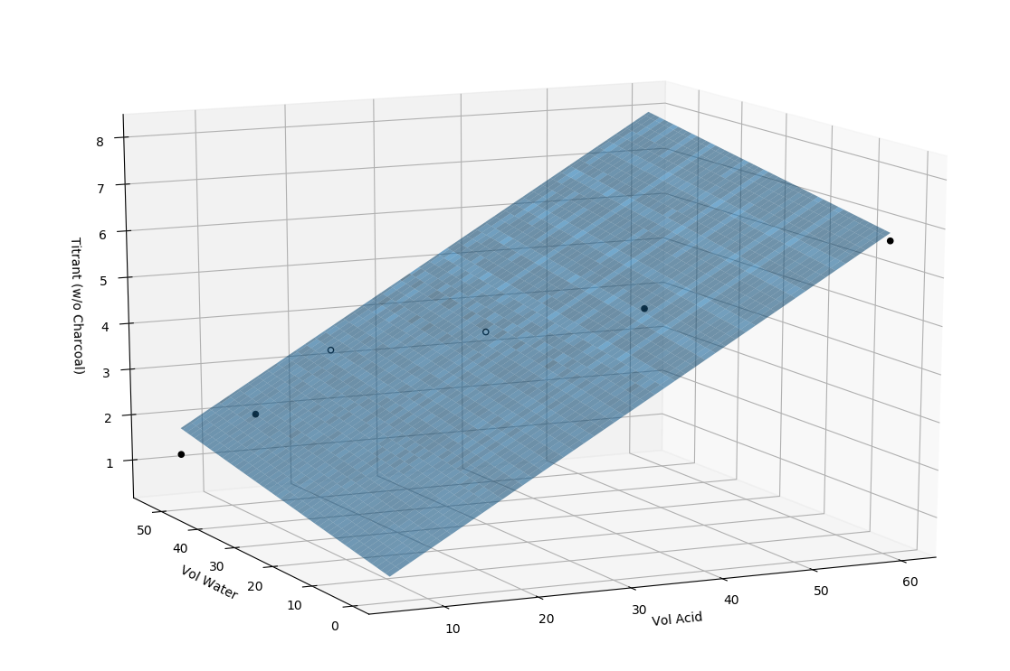**Figure 1:** 3D-Surface Plot of our statistical model for untreated assay (view 1)

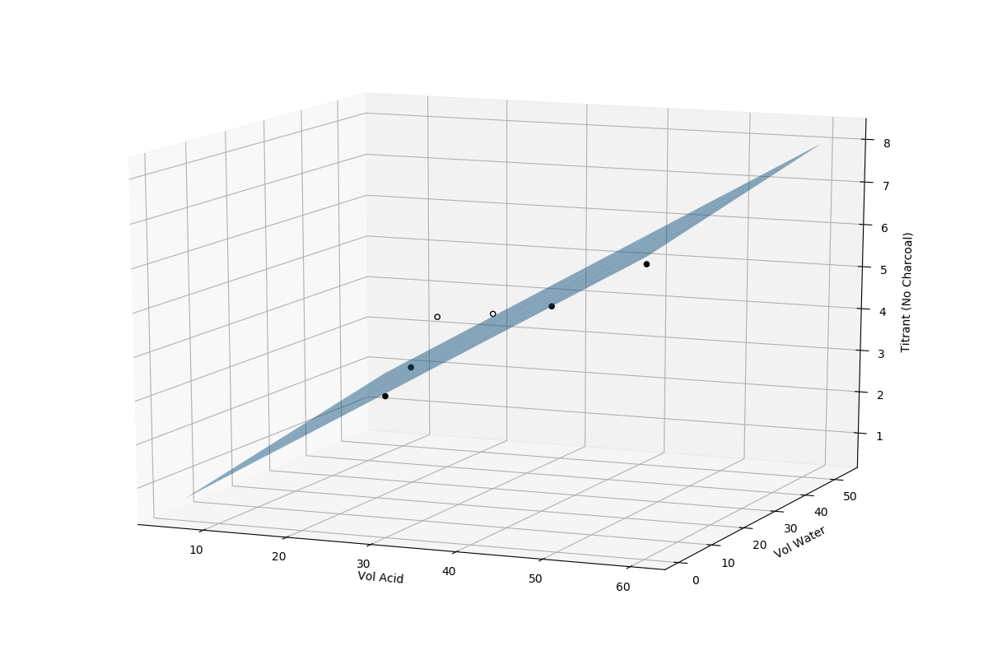

**Figure 2:** 3D-Surface Plot of our statistical model for untreated assay (view 2)

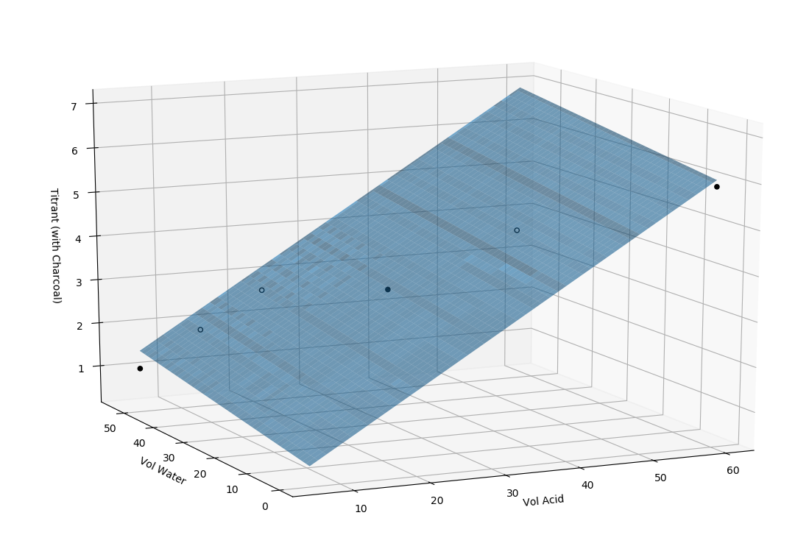

**Figure 3:** 3D-Surface Plot of our statistical model for charcoal-treated assay (view 1)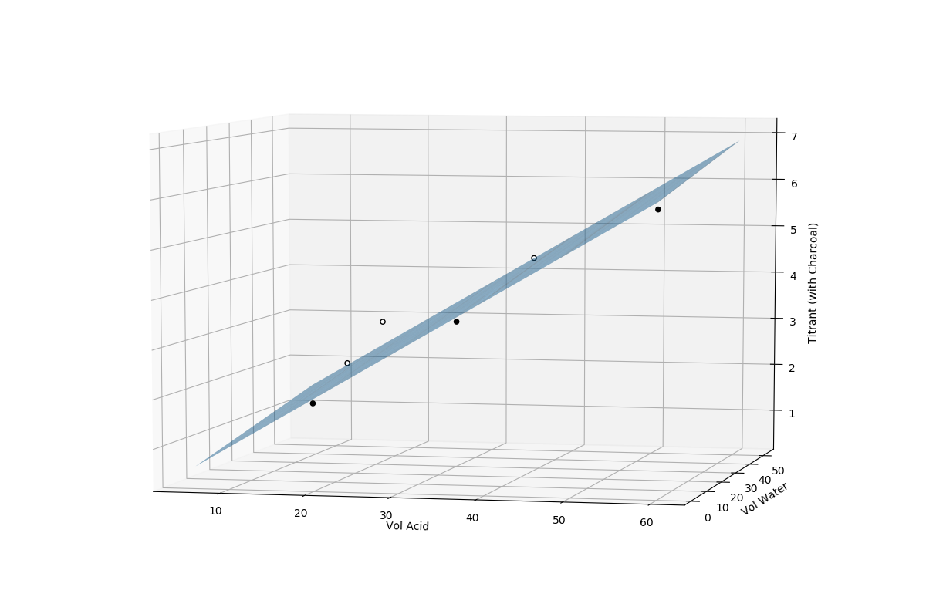 **Figure 4:** 3D-Surface Plot of our statistical model for charcoal-treated assay (view 2)

**Statistical Model Regression Summary**

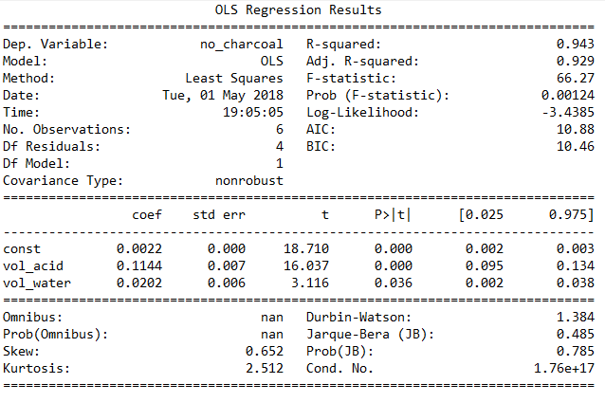**Figure 3:** Regression Summary for untreated assay

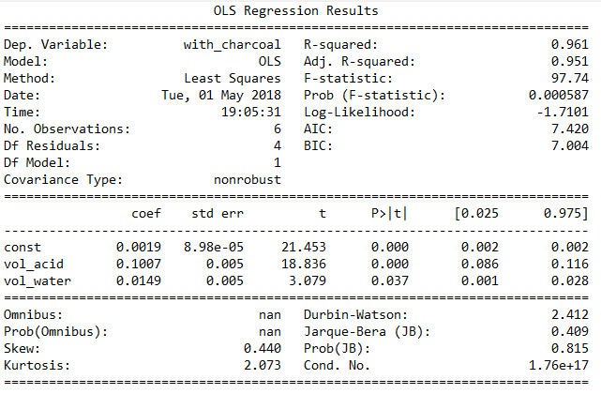

**Figure 3:** Regression Summary for charcoal-treated assay

**Statistical Model Python Code for Untreated Assay**

import pandas as pd

from sklearn import preprocessing, svm, model_selection

from sklearn.linear_model import LinearRegression

from matplotlib import pyplot as plt

import numpy as np

from matplotlib import cm

from mpl_toolkits.mplot3d import axes3d, Axes3D

from random import random, seed

import pickle

import statsmodels.api as sm

df = pd.read_csv('titration_data.csv')

x = df[['vol_acid', 'vol_water']]

y = df[['no_charcoal','with_charcoal']]

x_train, x_test, y_train, y_test = model_selection.train_test_split(x,y,test_size=0.2)

*#model = svm.SVR(kernel='linear')*

model = LinearRegression()

model.fit(x_train, y_train)

print(model.intercept_[0])

print(model.coef_[0])

print(model.coef_[1])

model_filename = 'titration.model'

pickle.dump(model, open(model_filename, 'wb'))

*# Plot*

X = df[['vol_acid', 'vol_water']]

y = df['no_charcoal']

X = sm.add_constant(X)

est = sm.OLS(y,X).fit()

xx1, xx2 = np.meshgrid(np.linspace(X.vol_acid.min(), X.vol_acid.max(), 100),

np.linspace(X.vol_water.min(), X.vol_water.max(), 100))

Z = est.params[0] + est.params[1] * xx1 + est.params[2] * xx2

fig = plt.figure(figsize=(12, 8))

ax = Axes3D(fig, azim=-115, elev=15)

surf = ax.plot_surface(xx1, xx2, Z, alpha=0.6, linewidth=0)

resid = y - est.predict(X)

ax.scatter(X[resid >= 0].vol_acid, X[resid >= 0].vol_water, y[resid >= 0], color='black', alpha=1.0, facecolor='white')

ax.scatter(X[resid < 0].vol_acid, X[resid < 0].vol_water, y[resid < 0], color='black', alpha=1.0)

*# set axis labels*

ax.set_xlabel('Vol Acid')

ax.set_ylabel('Vol Water')

ax.set_zlabel('Titrant (No Charcoal)')

print(est.summary())

plt.show()

***--- end of code (filename: model_no_charcoal.py) written May 5, 2018---***

**Statistical Model Python Code for Charcoal-Treated Assay**

import pandas as pd

from sklearn import preprocessing, svm, model_selection

from sklearn.linear_model import LinearRegression

from matplotlib import pyplot as plt

import numpy as np

from matplotlib import cm

from mpl_toolkits.mplot3d import axes3d, Axes3D

from random import random, seed

import pickle

import statsmodels.api as sm

df = pd.read_csv('titration_data.csv')

x = df[['vol_acid', 'vol_water']]

y = df[['no_charcoal','with_charcoal']]

x_train, x_test, y_train, y_test = model_selection.train_test_split(x,y,test_size=0.2)

*#model = svm.SVR(kernel='linear')*

model = LinearRegression()

model.fit(x_train, y_train)

print(model.intercept_[0])

print(model.coef_[0])

print(model.coef_[1])

model_filename = 'titration.model'

pickle.dump(model, open(model_filename, 'wb'))

*# Plot*

X = df[['vol_acid', 'vol_water']]

y = df['with_charcoal']

X = sm.add_constant(X)

est = sm.OLS(y,X).fit()

xx1, xx2 = np.meshgrid(np.linspace(X.vol_acid.min(), X.vol_acid.max(), 100),

np.linspace(X.vol_water.min(), X.vol_water.max(), 100))

Z = est.params[0] + est.params[1] * xx1 + est.params[2] * xx2

fig = plt.figure(figsize=(12, 8))

ax = Axes3D(fig, azim=-115, elev=15)

surf = ax.plot_surface(xx1, xx2, Z, alpha=0.6, linewidth=0)

resid = y - est.predict(X)

ax.scatter(X[resid >= 0].vol_acid, X[resid >= 0].vol_water, y[resid >= 0], color='black', alpha=1.0, facecolor='white')

ax.scatter(X[resid < 0].vol_acid, X[resid < 0].vol_water, y[resid < 0], color='black', alpha=1.0)

*# set axis labels*

ax.set_xlabel('Vol Acid')

ax.set_ylabel('Vol Water')

ax.set_zlabel('Titrant (with Charcoal)')

print(est.summary())

plt.show()

***--- end of code (filename: model_with_charcoal.py) written May 5, 2018---***

**Statistical Model Experimental Training Data**

*Format: CSV, Filename: titration_data.csv*

"vol_acid","vol_water","no_charcoal","with_charcoal"

6,54,1.2,1

12,48,2.2,2

18,42,3.7,3

30,30,4.3,3.2

42,18,5,4.7

60,0,6.7,5.9

**Statistical Model Equation**

**Not treated with charcoal:**

y = 0.04706704\**vol_acetic_acid* + 0.04241155\**vol_water* + 4.116201117318435

**Treated with charcoal:**

y = 0.04982993\**vol_acetic_acid* + 0.04345238\**vol_water* + 3.898979591836734

**NOTE:** This statistical model for our experiment is uploaded on my github account

**GitHub Account:** http://github.com/kristianespina

**Statistical Model:** https://github.com/kristianespina/Acetic-Acid-Adsorption-Charcoal-Statistical-Model